XXXVI International Seminar on Stability Problems for Stochastic Models
Second Information Letter
XXXVI International Seminar on Stability Problems for Stochastic Models will be held in Petrozavodsk, Karelia, Russia from 22 to 26 of June 2020 under the auspices of the Institute of Applied Mathematical Research of the Karelian Research Centre of the Russian Academy of Sciences (IAMR KRC RAS), Faculty of Computational Mathematics and Cybernetics of the Lomonosov Moscow State University, Institute of Informatics Problems of the Federal Research Scientific Center “Computer Science and Control” of the Russian Academy of Sciences and Moscow Centre of Fundamental and Applied Mathematics.
International Seminars on Stability Problems for Stochastic Models have a long tradition. They were founded by an outstanding mathematician Vladimir Zolotarev (27.02.1931–07.11.2019) in the 1970’s. The seminars are attended by leading specialists in probability theory and mathematical statistics from all over the world and traditionally aim at bringing together people from Eastern and Western Europe to share their expertise, new results, exchange the ideas and discuss open problems. In this century International Seminars were held in Bulgaria, Hungary, Italy, Israel, Latvia, Norway, Romania, Russia, Spain and Poland. Previous four Seminars took place in Perm, Russia (2018), Debrecen, Hungary (2017), Svetlogorsk, Russia (2016) and Trondheim, Norway (2014).

Conference venue
Petrozavodsk, the capital of Russian Karelia, stretches along the western coast of a large and beautiful Onego Lake. The city is the largest University and cultural centre in the North-West Russia.
Karelia region is famous for its “white nights”, the zenith of which falls on the days of the summer solstice – from June 20 to 22. At this time, night does not come here, the day lasts almost 19 hours, and the rest of the time is morning and evening.
The work of the seminar will be organized in the building of the Karelian Research Centre of the Russian Academy of Sciences (Pushkinskaya st., 11).

Registration and Abstracts
We would be very grateful if participants of the seminar will register and upload abstracts through online registration system on the Seminar website no later than April 1, 2020. WE KINDLY URGE YOU TO DO THIS AS SOON AS POSSIBLE!
After receiving the abstract and peer review, we will send to a corresponding participant an e-mail confirmation and an invitation to the Seminar (hard copies of Invitations will be given at the Registration desk).

Accommodation
ATTENTION! Please, book your accommodation in advance as soon as possible because in June 2020 extraordinarily many guests are expected in Petrozavodsk for the celebration of the 100th anniversary of Republic of Karelia.
For more detailed information on the recommended hotels, prices and discounts, please, check the section Accommodation of the Seminar website.

Visa information
Foreign participants WHO NEED VISA SUPPORT should AS SOON AS POSSIBLE CONTACT the local organizing committee by an e-mail address isspsm2020@krc.karelia.ru.
Information on Russian visa requirements can be found here: https://www.visatorussia.com/russianvisa.nsf/visa_requirements.html
Excursion
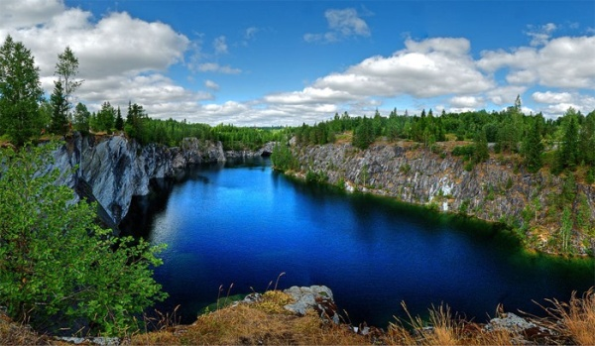
Within the cultural program we organize a tour to Ruskeala Mountain Park (some photo).
The Ruskeala Park is one of the most amazing places in North Ladoga region. Its most popular tourist attraction is Marble Canyon, a mining monument dated back to the end of the 18th and beginning of the 20th century and put on the Russian Federation Heritage List in 1998. There are no other monuments in Europe such as the monument which looks like a hand-made “bowl” found in the marble solid, cut through by mine, gallery and entry systems.
Estimated tour duration is 12 hours.
For successful organization of the tour, please, fill the corresponding information in your Participant Application in the Personal Account no later than June 1.

Personal Account
ATTENTION! Registered participants of the Seminar, please, check your Personal Account and make sure that you filled in all the fields in your Participant Application form!

Accompanying publications
The Seminar is accompanied by three types of publications.
1. Each participant will be supplied by the book of Abstracts of the Seminar upon arrival and registration.
2. Proceedings of the Seminar will be published in three special issues of the "Journal of Mathematical Sciences". The details will be announced at the Seminar.
3. A special issue of the open access journal "Mathematics" (WoS Q1) dedicated to the memory of Vladimir Zolotarev is now being assembled. All the participants are welcome with their papers. For more information see https://www.mdpi.com/journal/mathematics/special_issues/Stochastic_Processes_Theory_Applications_2020

Seminar website: isspsm2020.krc.karelia.ru

If you have any questions, please, contact isspsm2020@krc.karelia.ru

On behalf of the International Program Committee,
Victor Korolev, Chairman
Irina Shevtsova, Vice-Chairman

On behalf of the Local Organizing Committee,
Vladimir Mazalov, Chairman
Evsey Morozov, Vice-Chairman

